Final Project for SW Engineering

Class CSC648/848 Fall 2023

Team 02

California SafetyNet

Lukas – lheber@sfsu.edu – Team Lead, Github Master
Marshall – back end lead
Ely, Mark, Sanjith

Demo: California SafetyNet

Date: 12/5/2023

Content
1. Product summary 3
2. Screenshots of final product 4
3. Key database tables 5
4. Google analytics plot 6
5. Use of task management system 7
6. Team member contributions 8
7. Post analysis 10

1. Product summary
California Safety Net
- Potential users shall be able to sign-up to the site and if needed shall then be authorized by administrators as official figures that can initiate alerts
- Registered and authorized users shall be able to initiate alerts to the general public in one “their” category, which is one of the following four: 1. Security, 2. Health, 3. Weather and 4. Fire
- Users shall be able to access a map that allows an overview of alerts for different counties
- Besides the map users shall be able to search and filter alerts to get an overview for example for planning a trip inside the state of California

California Safety Net allows its users an easy way to stay safe and informed. Registered users are alerted by county officials should it be necessary. This helps to always keep the Californian public safe. A big aid in this is the extensive map feature that allows users to get an overview of the whole state of California and its safety situation. This enables planning trips during the fire season and provides a feeling of safety to its users. Fall into the reassurance provided by California Safety Net today!

Link to California Safety Net: California SafetyNet (softwareengineering.servehttp.com)

2. Screenshots of final product
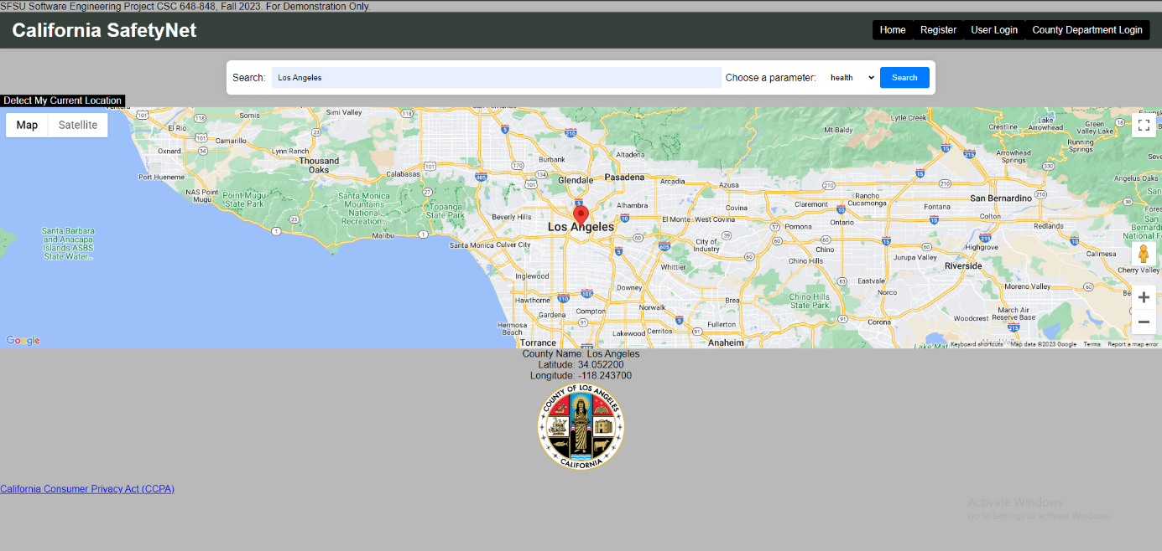
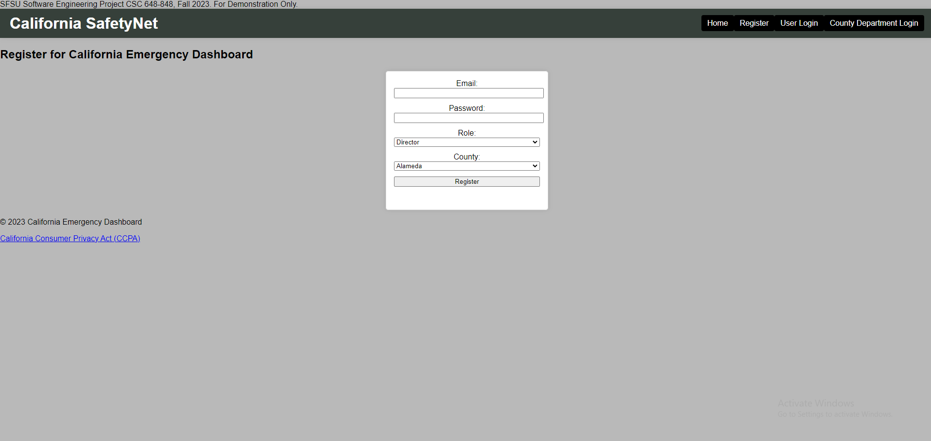
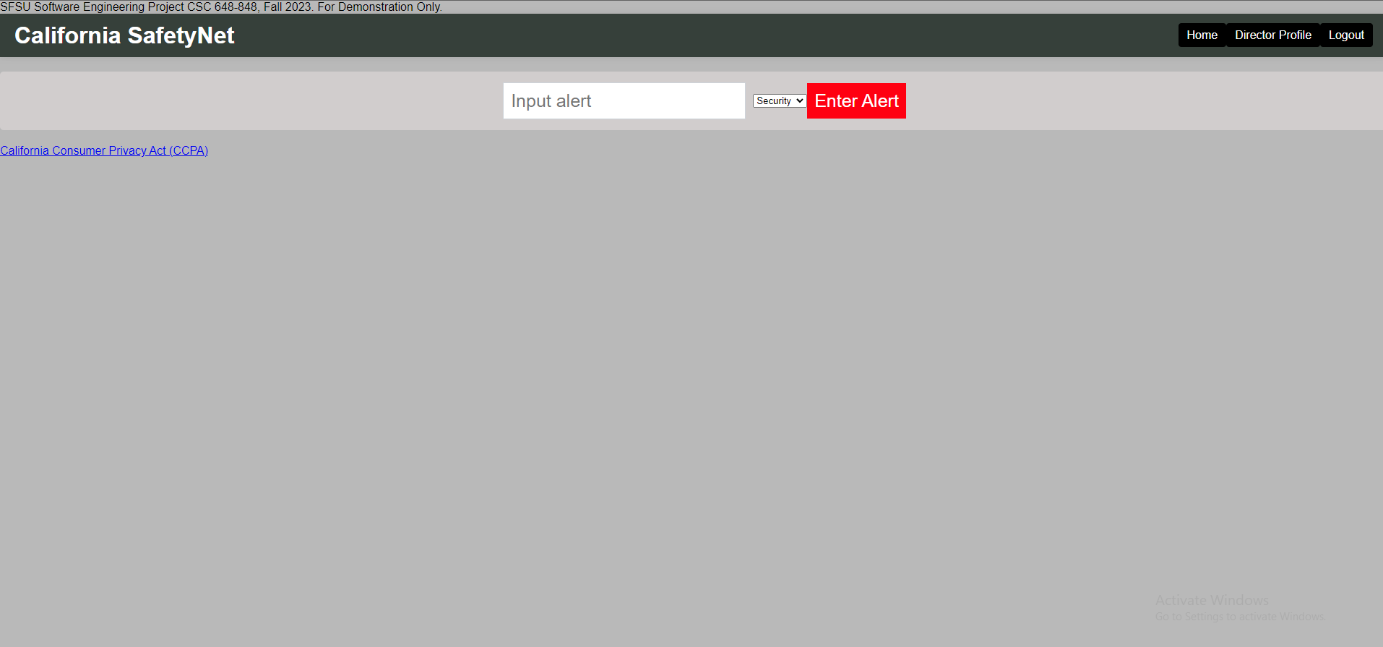
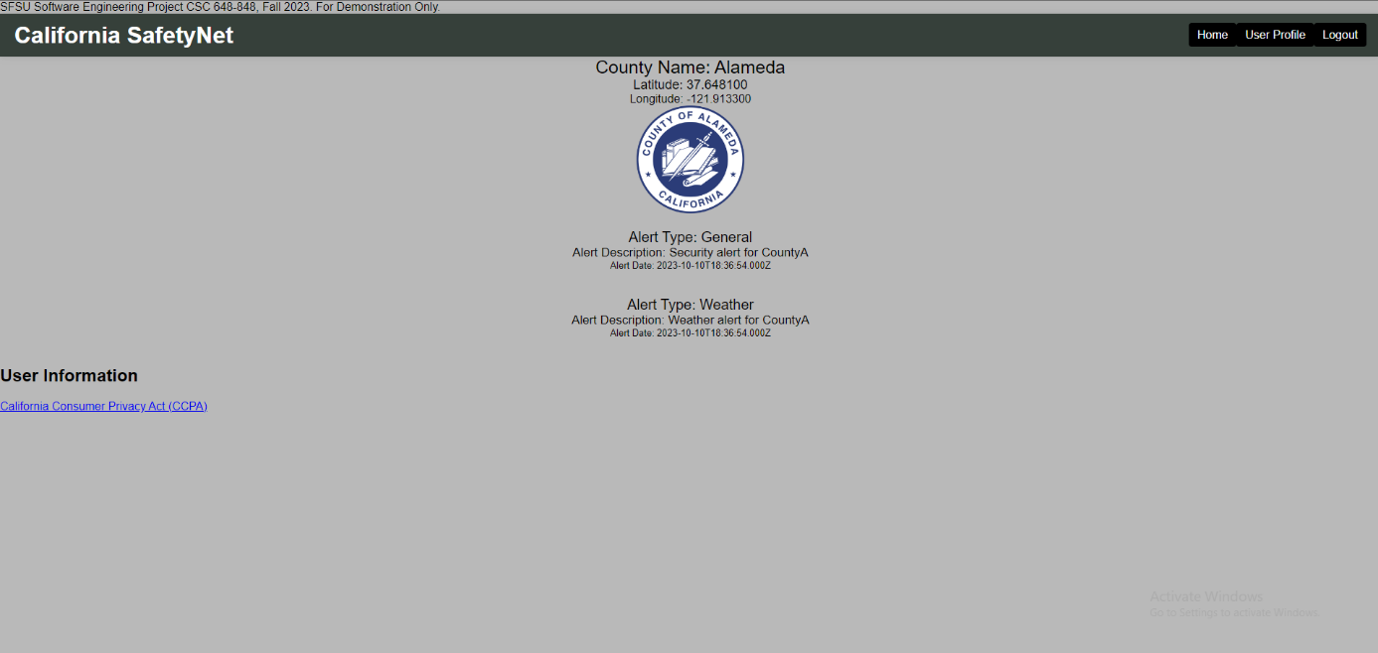
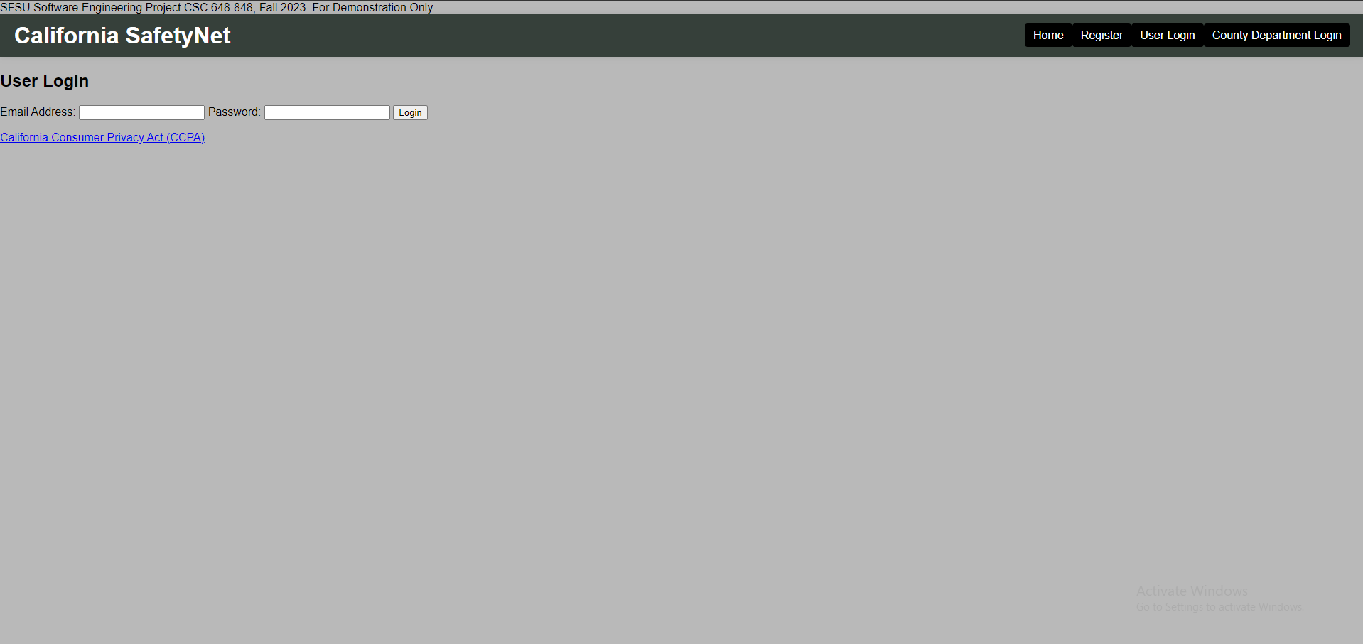

3. Key database tables
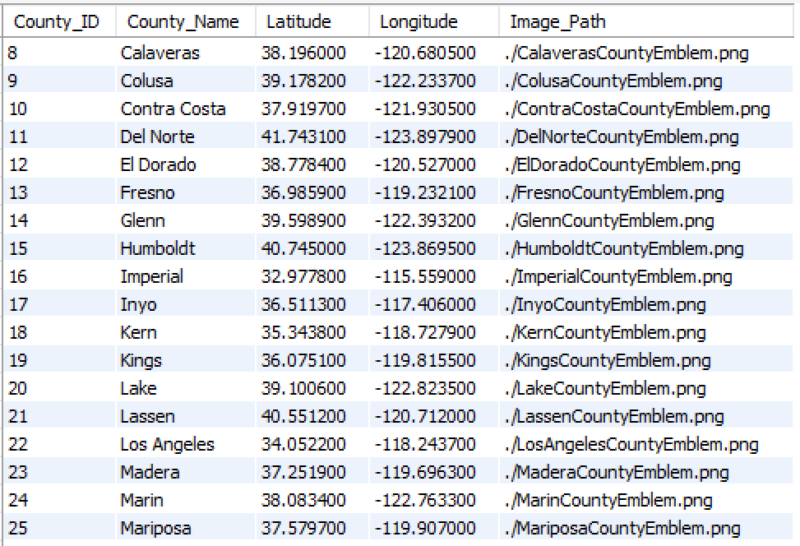
Table 1: County
Table 2: User
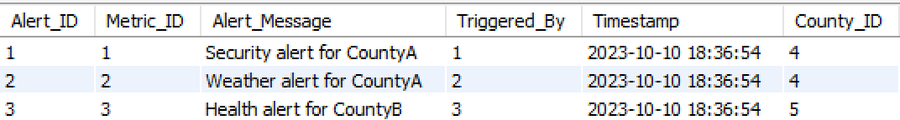
Table 3: Alert

4. Google analytics plot
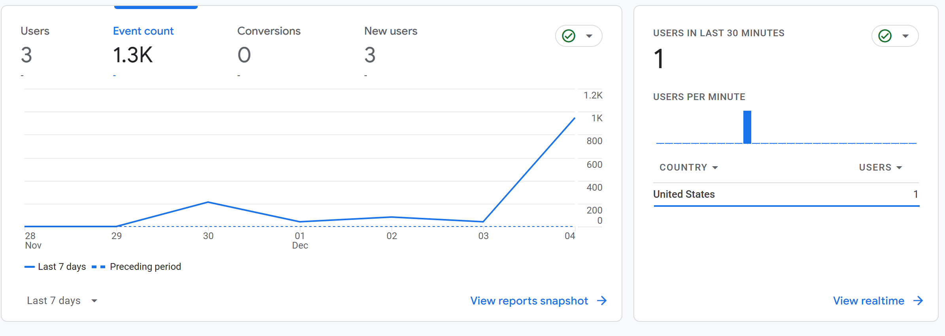

5. Use of task management system
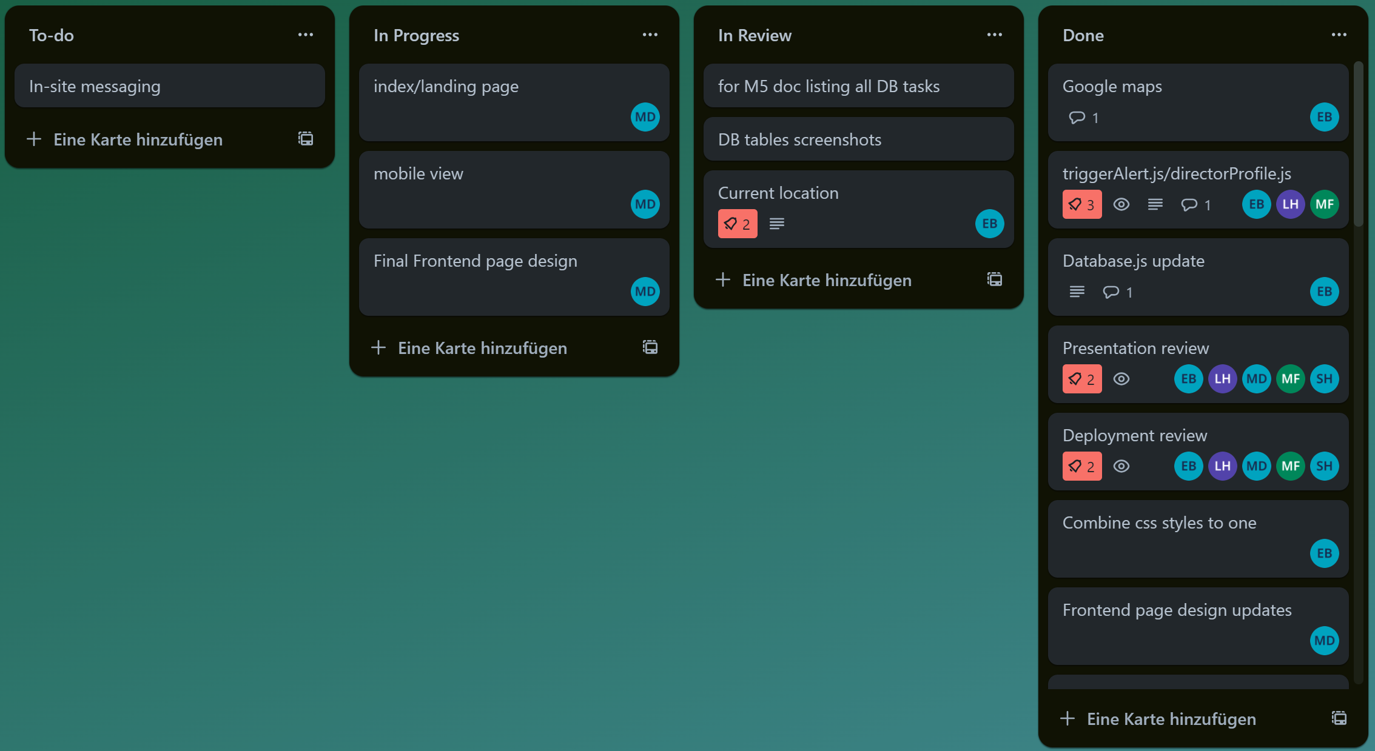

6. Team member contributions
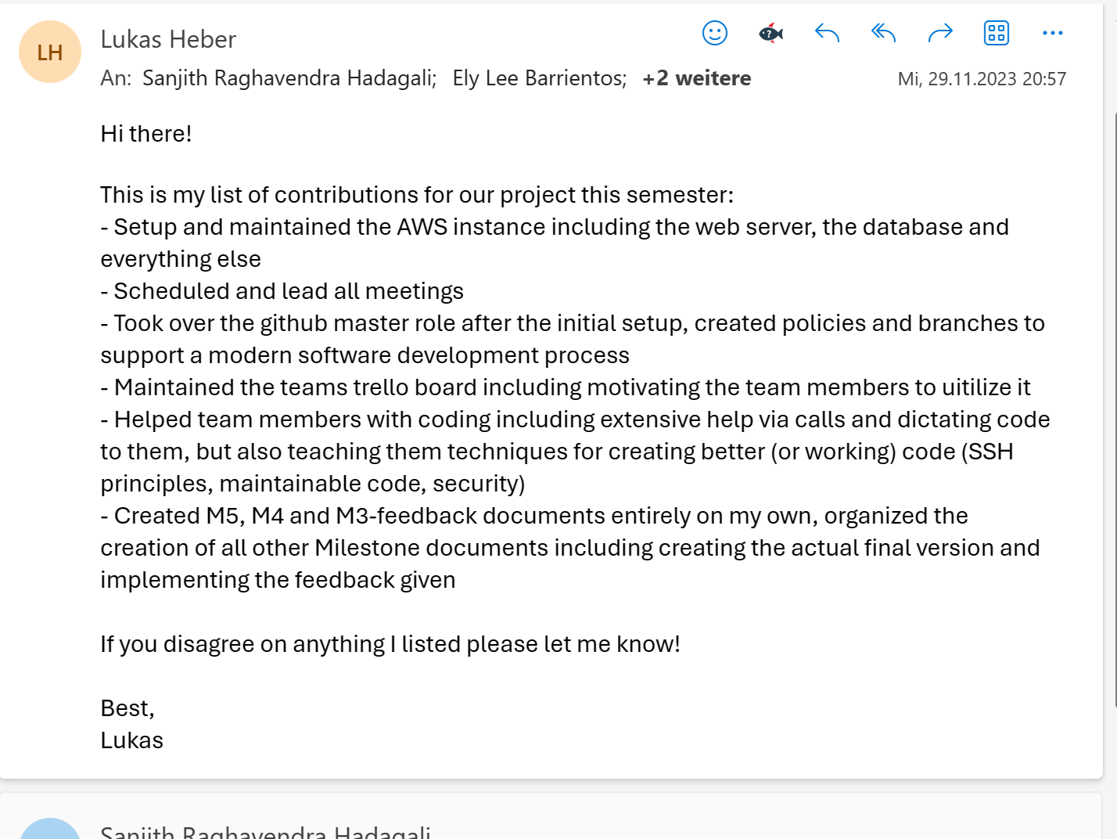
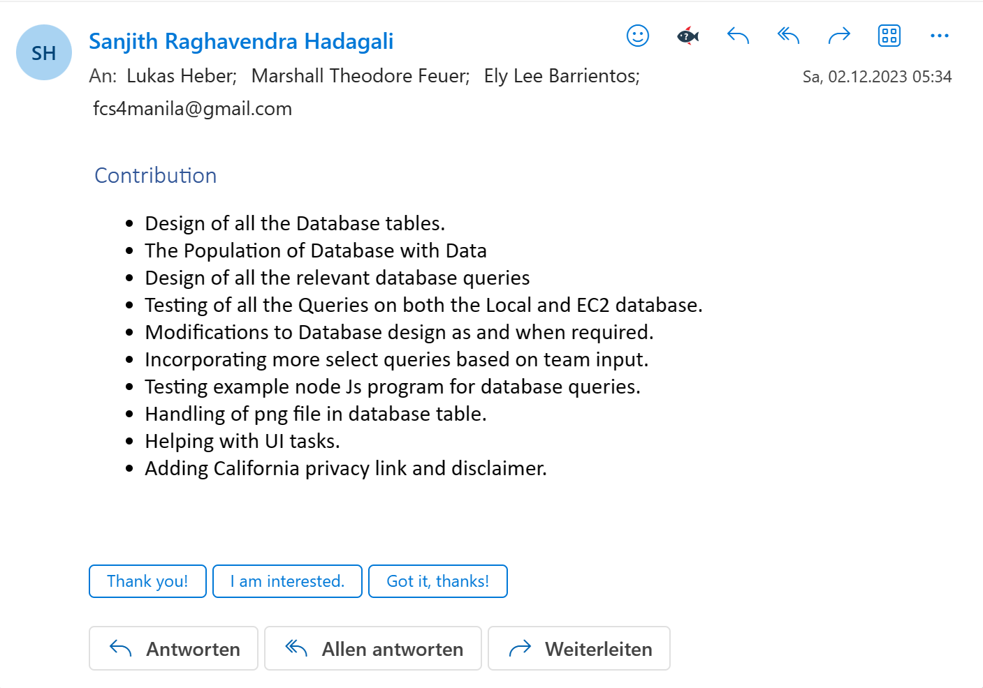

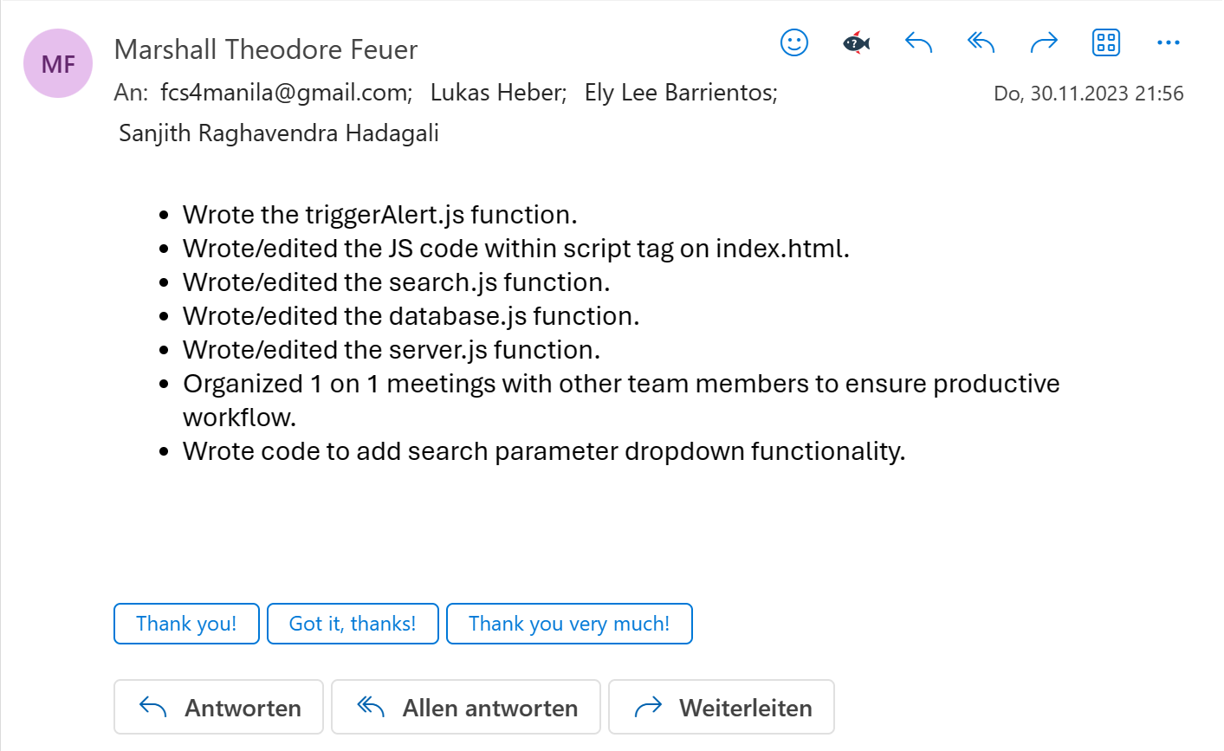
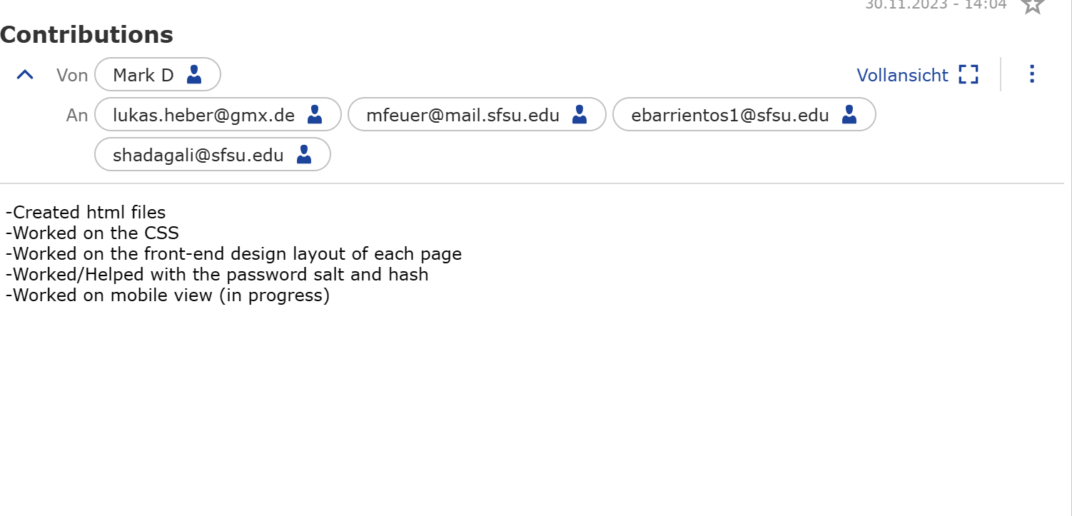
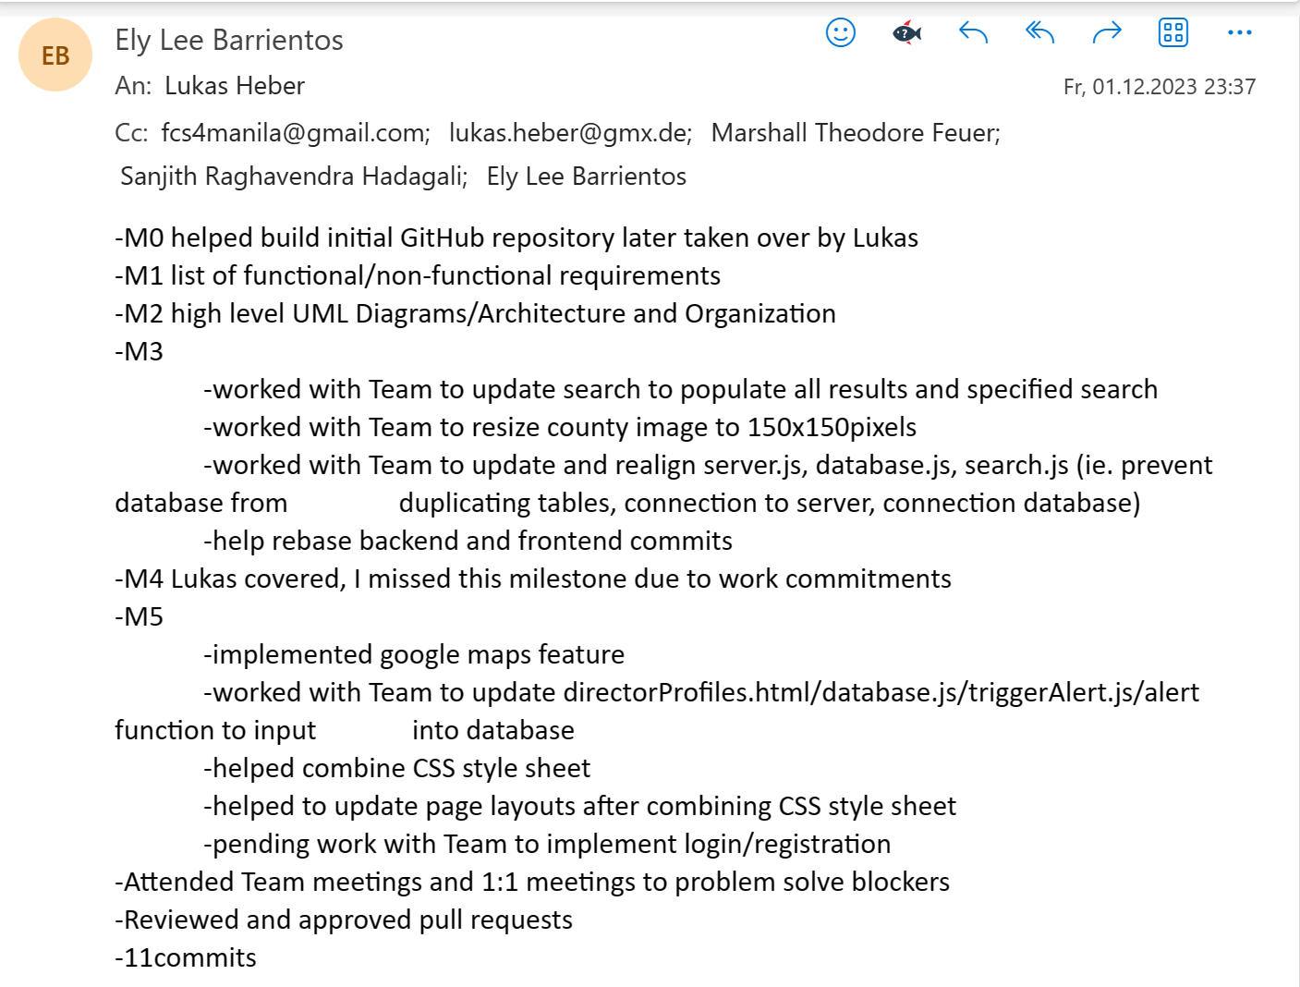

7. Post analysis
Collaborating with the team on the project posed a challenge given the diverse skill levels within our group. However, varying and sometimes lacking levels of proficiency in the chosen technologies became a recurring hurdle for the team throughout the project.
In an attempt to empower individuals within the team, I experimented with providing more autonomy for independent work and pacing. Regrettably, this approach resulted in a notable slowdown in our progress, with competing priorities from other classes taking precedence for some team members.
Another big issue was scheduling meetings that everyone could attend due to work, other classes and other responsibilities. This wasn’t helped by team members regularly missing our normal class time and/or our other meetings sometimes without any note. I don’t really see a way to counter that behavior with the power that was given to me by the mode of the class, so I don’t have an idea how I would counter this behavior in the future.
Contrary to these challenges, engaging in team discussions and conducting brief training sessions emerged as very valuable experiences, shedding light on the unique dynamics within our group. Moreover, transitioning to a scrum schedule, particularly the daily scrum meetings, played a pivotal role in enhancing accountability for the progress being made and fostering transparency and knowledge sharing among team members. This positive outcome further solidified my appreciation for agile methodologies, particularly scrum and was definitely the right thing in our situation.
Additionally, taking on too many tasks, particularly server maintenance, proved counterproductive, as it left me as the sole team member proficient in this area. In future situations, I would opt for collaboration with at least one other team member to distribute knowledge and responsibilities more effectively.
Finally, I should have taken over more of the coding responsibilities after discovering the issues my team members had, this would have allowed us to progress faster as a team and lead to a better result. This is definitely a big error of judgment on my part since I didn’t realize that that would be necessary in our situation.

